Weekly Notes November 18, 2019
Ford Early LearningCenter
Ypsilanti Community Schools
Principal: Mumtaz Haque

Ford ELC Classrooms

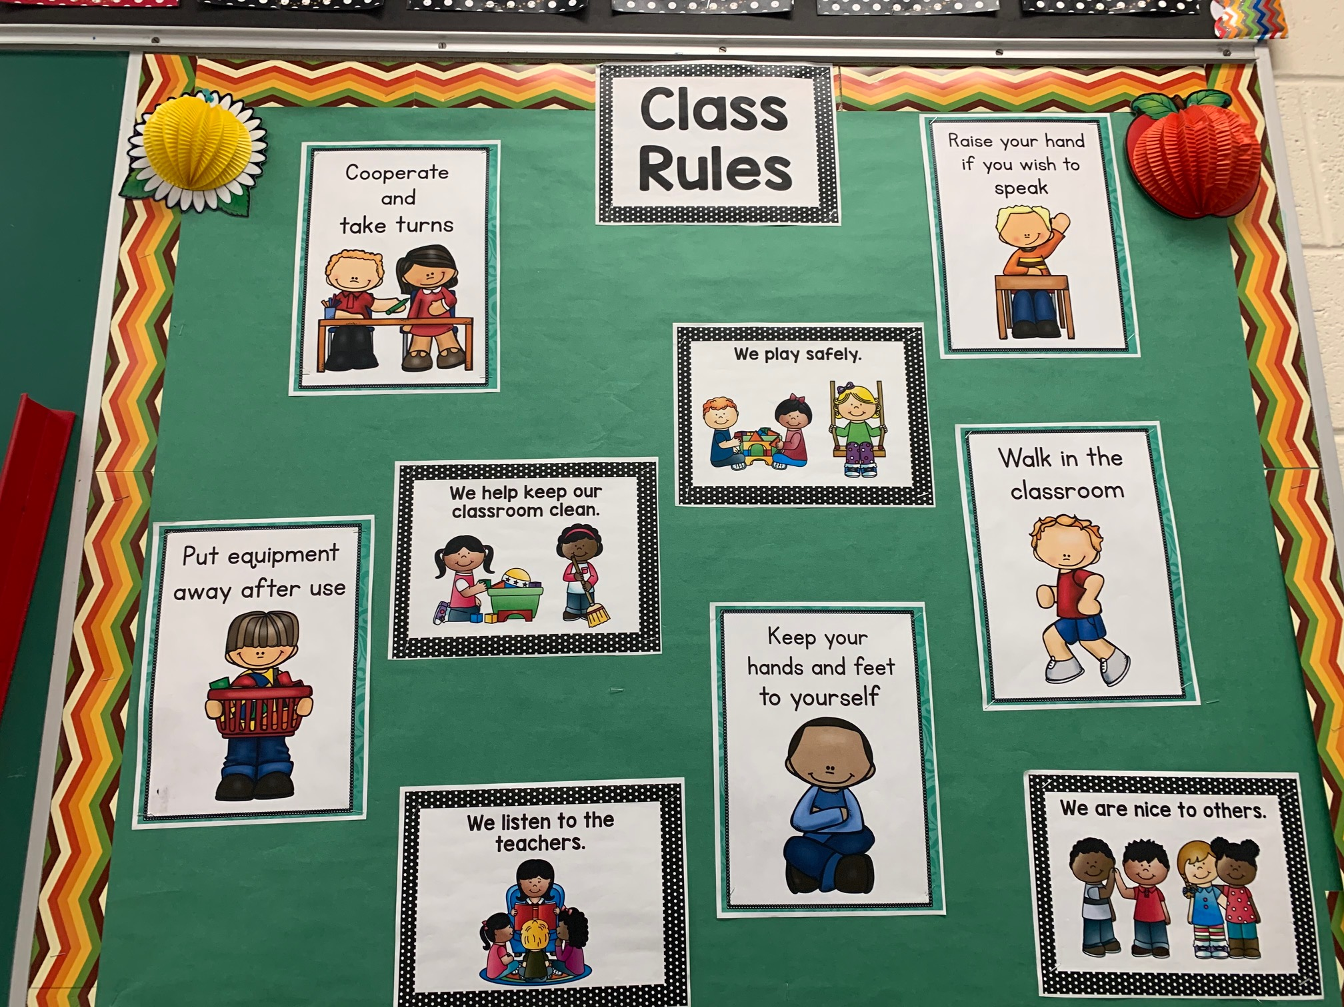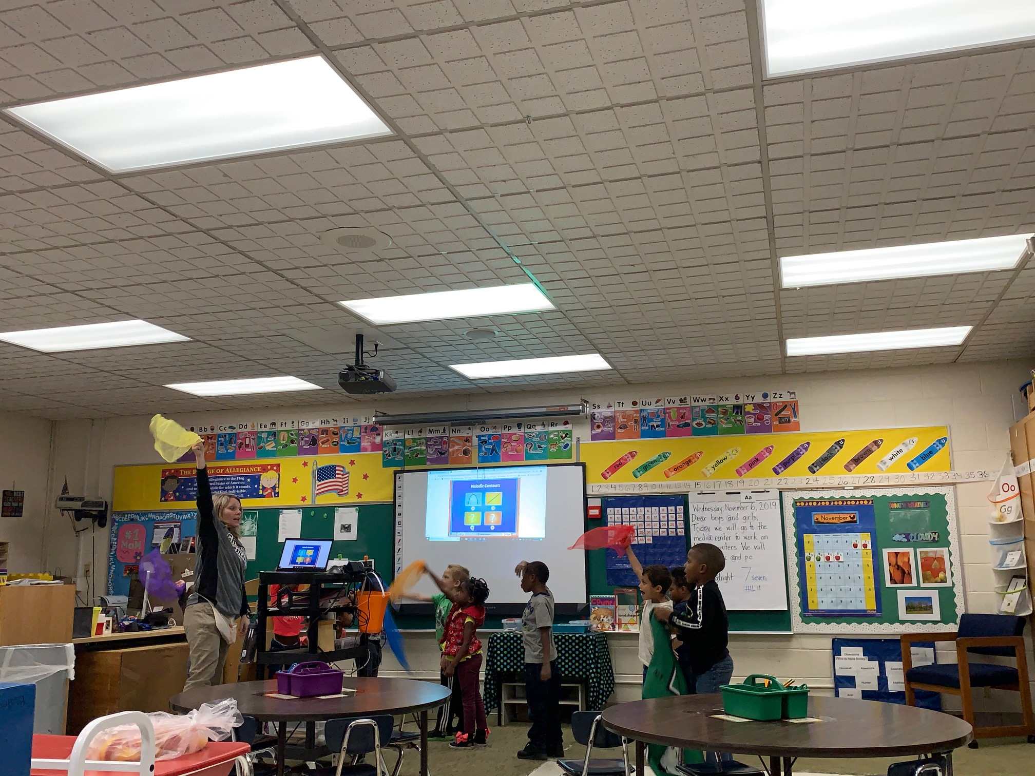

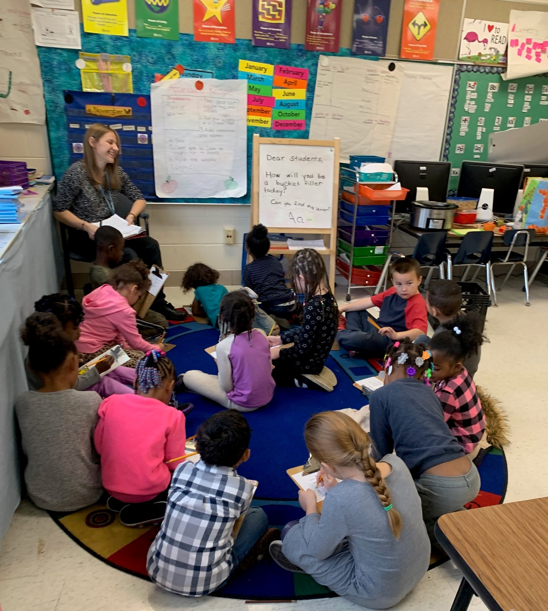

Monday, November 18 Lesson plans due
Classroom Observations

Tuesday, November 19 Classroom Observations
Post Observation Meetings
Staff Meeting: Training in
De-escalation Techniques
Presenter: Nicole Revels (WISD)

Wednesday, November 20 Classroom Observations
Post Observation Meetings

Thursday, November 21 Classroom Observations
Post Observation Meeting

Friday, November 22 Classroom Observations
Post Observation Meetings
IMPORTANT NOTES
- Classroom observations of teachers are ongoing. Please have a copy of the attached pre-observation form ready with you in addition to your lesson plan for each day. I have already shared a sign-up sheet (Google Doc); however, all observations may not take place as scheduled due to unforeseen emergency. As I shared with you, I will be visiting/observing all classrooms. Several of you have already invited me to visit your class any time – thank you!!! Please be sure to email me your lesson plans on a timely basis.
- Ford Staff will receive a PD on De-escalation Strategies during our PLC meeting on Tuesday, November 19, 2019. Ms. Nicole Revels, Teacher Consultant from Washtenaw ISD will facilitate the training.
FOCUS OF THE WEEK
- Lesson Plans for the week are due every Sunday. Please note, this is a mandatory requirement. Thank you to all those who have been submitting their lesson plans on a timely basis.
- Please be sure to enter your AM and PM attendance in the PowerSchool daily. Please note: it is the teacher’s responsibility to complete attendance (AM and PM) each day.
- Be sure to revisit your classroom expectations with students every morning.
- All students are to engage in Higher Order Thinking/Critical Thinking. I have included in this document samples of questions that develop higher order thinking in students.
BEST INSTRUCTIONAL PRACTICES
- Learning Target (I can….) aligned with the Common Core State Standards posted on Board
- Rigorous Lessons/Activities
- Student Centered Classrooms (Teacher serves as facilitator)
- Higher Order Thinking Questions (DOK) being asked and brainstormed. For lower elementary classes you may have to define and simplify the key words such as recall, identify, summarize etc.
- Group work – with students engaged in higher order thinking and teacher serving as a facilitator.
- Differentiated instruction for students who need extra assistance.

Kindergarten Common Core State Standards for Math

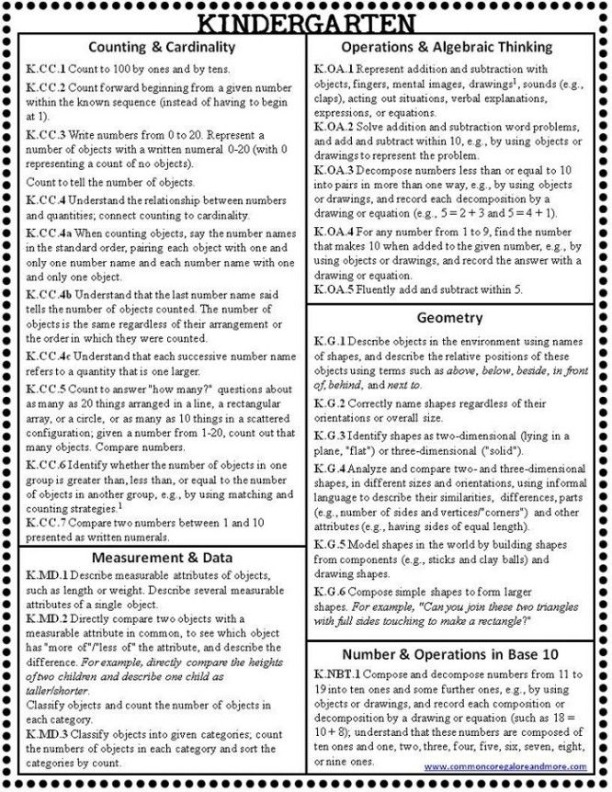

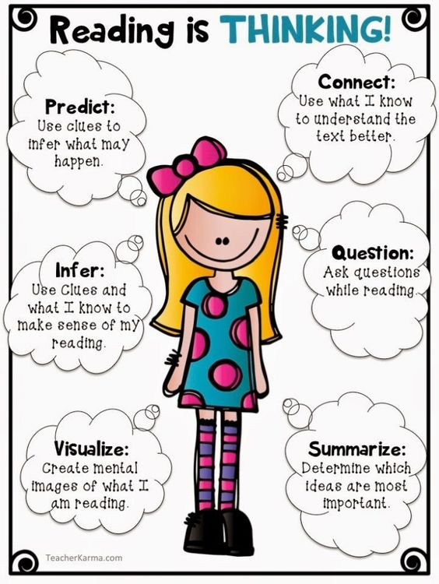

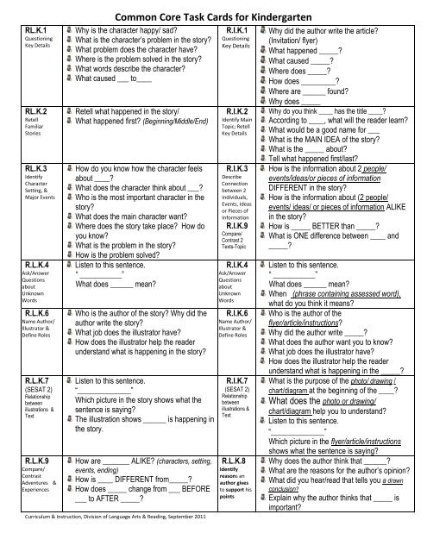

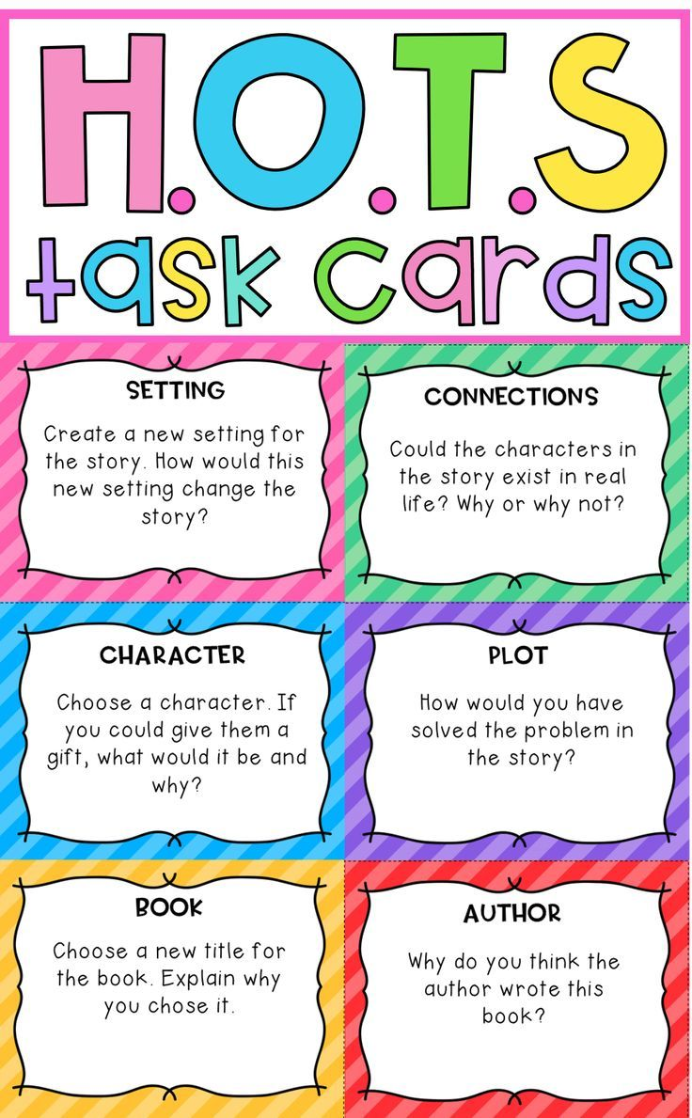
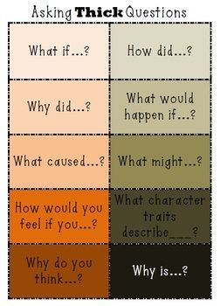
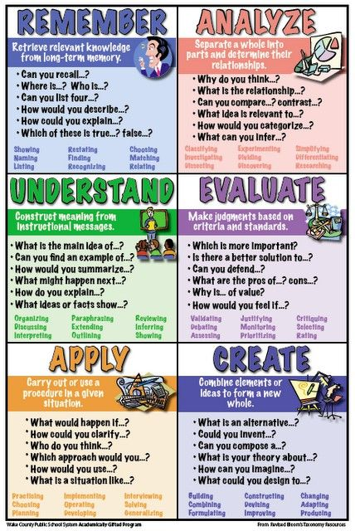

Higher-Order-Thinking Activities for Preschoolers
Teacher's often use Benjamin Bloom's taxonomy of thinking skills when planning their curriculum. Bloom includes in his taxonomy lower-order-thinking skills such as knowledge, comprehension and application as well as higher-order-thinking skills like synthesis, evaluation and analysis. Teachers can develop higher-order-thinking skills in preschoolers by teaching them to question why something occurred, how it occurred or how it might have occurred differently.

Story Time
Critical thinking occurs when teachers challenge their students. Teachers can teach higher-order-thinking skills to their preschoolers through the questions they ask after reading a story during circle time -- questions like, "Which part of the story did you like best," followed by "How come?" Another question to challenge your preschool students is, "Can you think of another way the story could have ended?" or "Do you like the way the story ended?" These questions encourage a deeper level of thinking while keeping the activity age-appropriate and in line with the curriculum.
Teacher's often use Benjamin Bloom's taxonomy of thinking skills when planning their curriculum. Bloom includes in his taxonomy lower-order-thinking skills such as knowledge, comprehension and application as well as higher-order-thinking skills like synthesis, evaluation and analysis. Teachers can develop higher-order-thinking skills in preschoolers by teaching them to question why something occurred, how it occurred or how it might have occurred differently.

Hoop Game
Preschoolers can easily understand the concept of the hoop game, although finding a solution to the problem requires deeper thinking and working with their classmates. Try to break your students into groups no larger than six. Place two hula hoops side by side on the floor. Instruct your students to put all their orange dinosaurs inside one hoop and all the T-Rex dinosaurs in the other hoop. Students will meet their challenge when they discover that one of the dinosaurs is an orange T-Rex. Listen to the ideas your students come up with. Encourage their communication and suggestions without directing. Ask your students, without giving the answer, if they can think of a way to put both hoops together so the orange T-Rex is in both hoops. If needed, show them how to do this.
Teacher's often use Benjamin Bloom's taxonomy of thinking skills when planning their curriculum. Bloom includes in his taxonomy lower-order-thinking skills such as knowledge, comprehension and application as well as higher-order-thinking skills like synthesis, evaluation and analysis. Teachers can develop higher-order-thinking skills in preschoolers by teaching them to question why something occurred, how it occurred or how it might have occurred differently.
Volume 0%

Which One's Missing
This game is best played one-on-one or in small groups. Another alternative is to divide your class into small groups and play as teams. Place five or six objects such as colorful ducks or toy cars in a row on the table. Have your students study the objects for about 30 seconds. Instruct them to close their eyes and take one object away. As students improve, take more objects away. Push the objects closer together to close the gap. The students' job is to tell you what is missing and where in line it was.
Teacher's often use Benjamin Bloom's taxonomy of thinking skills when planning their curriculum. Bloom includes in his taxonomy lower-order-thinking skills such as knowledge, comprehension and application as well as higher-order-thinking skills like synthesis, evaluation and analysis. Teachers can develop higher-order-thinking skills in preschoolers by teaching them to question why something occurred, how it occurred or how it might have occurred differently.

Patterns
Making patterns is an excellent thinking activity and can be used with individual students or an entire group. If students become confused during the process, repeat the pattern then ask, "Now what?" Colorful wooden blocks can be set up for students to continue the pattern, or verbal directions can be given to make a pattern with blocks. Students can create their own patterns and verbalize them to you. They can work in small groups to create complex patterns. Worksheets can be used to color patterns. Felt boards with colorful shapes work well, too. Students can also create jewelry patterns with multi-colored beads. These can serve as a wonderful gift for mom.

